TNSPARK - DOCUMENTATION

- Name of the Training: TNSPARK
- Spells : 1 (07.8.2025 & 08.8.2025) – 2 days
- Venue : KSR College of Engineering. Tiruchengode
- Details of the RP :

S.NO | NAME, DESIGANATION & SCHOOL ADDRESS
1 | V. RAMESH  B.T (MATHS)  GGSS , MOHANUR 9787161897
2 | R. CHANDRASEKARAN  B.T (SCIENCE)  GHS, NATHUKULIPATTI 7639812278
3 | M. RAJENDRAN  COMPUTER INSTRUCTOR  GHSS, SIVNANDA SALAI, RASIPURAM 9865308770
4 | M. GOPINATH  COMPUTER INSTRUCTOR GHSS, POTHANUR 9865203010
5 | P. TAMILSELVAN  PGT  GHSS, VALAYAPATTI
6 | R. KAVITHA  B.T  PUMS, NARAYANIPALAYAM TIRUCHENGODE 9659688777
7 | SURESHKUMAR  PGT  GHSS, ANNASALAI RASIPURAM

- Target group : TNSPARK Nodal Teachers in Namakkal District
- No of Participants Attended: 55
- Training Time table :

DISTRICT INSTITUTE OF EDUCATION AND TRAINING, NAMAKKAL
TN SPARK TIME TABLE
DETAILS OF SESSION
DAY 1 (07.8.2025)
Session 1 FC Fundamentals of Computer / Class 6
1. Mouse Games, Tux typing
2. Hi tech lab intro
3. Boss intro
4. Tux typing 2 module
5. Mouse house game
6. Algorithm and flowchart
Class 7
7. Libre paint
8. Libre writer
9. Browser

Session 2- Online Tools
Online tools – Class 6
1. Pschool
2. Stellarium
3. Explore Anatomy
Class 7
4. Molecule
5. Google Earth
6. Games to learn English
7. Geogebra (1) Class 6,7
8.Geometric Straight line / line segment (Class 6)
9.Geometric Types of Angles (Class 6)
10.Geometric Types of Triangles (Class 7)
11.Drawing Triangles (Measuring Angles)(Class 7)

Session 3 Python
Phython 1
1. Problem Solving Technique
2. Say Hi to Python
3. Tokens and Data types
4. Giving input and getting output

Session 4 –Artificial Intelligence
1. Intro to AI and Machine learning AI class 6
2. Quick Draw
3. Smart search
4. Magic Sketch pad
5. Image generator
6. Paint with Music

DAY 2 (08.8.2025)
Session 1 –FC
LibreCalc (8 Std) Libre Impress (9 Std)
Session 2 –Python 2
(4 titles Class 9) Control Structure Looping Statements Jump Statements
Functions to perform tasks
Session 3- Artificial Intelligence
7. Class 7 Code. org
8. Autodraw
9. Thirukkural
10. Voice generator
11. Mindmap AI
12. Class 8 Google translate
13. ChatGPT
14. Metademolab
15. Suno
16. 3DAnimation
Session 4 – Online Tools 2 Std-8; Std-9 Geogebra
1. . Class 8 Parts of circle (Part1 , Part2)
2. Class 9 Plot the Points linear equation
3. Class Class 8 waves Intro
4. Map maker
5. Class 9 Ptable
6. Virtuai tour
- Brief Note about the Training:
TNSPARK Stands for Tamil Nadu School Programme for Artificial Intelligence, Robotics and knowledge of Online Tools.
It is an initiative launched by the School Education Department in Tamil Nadu, India, to introduce Students in Classes 6 to 9 to a comprehensive curriculum covering:
  - Artificial Intelligence (AI): The program aims to teach Students the fundamentals of AI and how to use AI tools.
  - Robotics
  - It includes learning about robotics, providing hands-on experience in the field.
  - Coding: Students are taught coding to build foundational computer science Skills.
  - Online Tools: The program also focuses on teaching students about various online tools and their practical applications for daily use.
The Program utilizes high –tech labs in government schools, and teachers receive special training to impart these skills to Students. The goal is to prepare Students with advanced knowledge in these emerging fields.
TNSPARK is a training program designed for teachers to enhance their skills in using technology and innovative teaching methods using ICT technology. This training promotes students’ learning.

The Program focuses on
- Fundamentals of Computer
- Online tools
- Python
- Artificial intelligence
The goal of TNSPARK training for teachers is to equip with the necessary skills and knowledge to enhance student learning and improve teaching practices in the digital age.

- Session Wise: Detailed Report
Inauguration:
The TNSPARK Training program for Namakkal teachers was inaugurated on 7.8.2025 at K.S.R College of Engineering by Principal. DIET.Namakkal, who emphasized the importance of skill development and innovative training for teachers. The program aims to equip teachers with emerging technologies and leadership skills to enhance the overall growth of the teaching – learning Strategies.

TNSPARK TRAINING
Date: 07.8.2025 & 08.8.2025
Venue: KSR College of Engineering Tiruchengode
Session :1 Resource Person – Mr.Chandrasekaran

Topic: Fundamental of Computer (FC)
The resource Person Mr.Chandrasekaran explained basics of ICT skills,

Demonstrated to teachers and developed Skills of the teachers by hands on practice. Teachers gained basic computer skills.
He covered the following topics:
- Mouse Games, Tux typing
- Hi tech lab introduction
- Boss introduction
- Tux typing 2 module
- Mouse house game
- Algorithm and flowchart
- Libre paint
- Libre Writer
- Browser

Session :2 Resource Persons – Mrs. Kavitha & Mr. Ramesh
Topic: Online tools

The resource Person Mrs. Kavitha covered std 6,7 for languages, Science and Social Science online tools. Firstly, she Explained the online tools and demonstrated online tools, after that hands on practice for teachers was given.
Covered topics:
Session :2

1. Pschool
2. Stellarium
3. Explore Anatomy
4. Molecule
5. Google Earth
6. Games to learn English

The resource person Mr. Ramesh Covered Std -6,7 for mathematics online tools.
Firstly, explained online tools by PPT, demonstrated online tools and after that hands on practice for teachers.
Covered topics:

1. Geogebra (1) Class 6,7
2. Geometric Straight line / line segment (Class 6)
3. Geometric Types of Angles (Class 6)
4. Geometric Types of Triangles (Class 7)
5. Drawing Triangles (Measuring Angles) (Class 7)

Session :3 Resource Person – Mr.Gopi

Topic: Python
The resource person Mr. Gopi explained python. by PPT, demonstrated to teachers and after that hands on practices for teachers.
Covered topics:

1. Problem Solving Technique
2. Say Hi to Python
3. Tokens and Data types
4. Giving input and getting output
Session :4 Resource Person – Mr.Tamilselvan

Topic: AI Tools
The resource person Mr. Tamilselvan explained AI. by PPT demonstrated to teaches and after that hands on practices for teachers.

Covered topics:

1. Intro to AI and Machine learning AI class 6
2. Quick Draw
3. Smart search
4.Magic Sketch pad
5.Image generator
6.Paint with Music
Session :5 Resource Person – Mr.Sureshkumar

Topic: Libre calc, Impress
. The resource Person Mr.Sureshkumar explained basics of ICT skills, Demonstrated to

teachers LibreCalc (8 Std) and Libre Impress (9 Std) and was developed Skills of the teachers by hands on practice. Teachers gained basic computer calculation skills.
Covered topics:
  - LibreCalc (8 Std)
  - Libre Impress (9 Std)
Session :6 Resource Person – Mr.Rajendran

Topic: Python 2
The resource person Mr. Rajendran explained python2. by PPT, demonstrated to teachers and after that hands on practices for teachers.
Covered topics:

Class 9 1. Control Structure

    - Looping Statements

    - Jump Statements

    - Functions to perform tasks

Session :7 Resource Person – Mr.Tamilselvan

Topic: AI Tools
The resource person Mr. Tamilselvan explained AI. by PPT, demonstrated to teaches and after that hands on practices for teachers was given.

Covered topics:

Class 7 Code. org
1.Autodraw
2.Thirukkural
3.Voice generator
4.Mindmap AI
5.Class 8 Google translate
6.ChatGPT
7. Metademolab
8. Suno
9.3DAnimation
Session :8 Resource Person – Mr.Ramesh

Topic: Geogebra, basic online tools
. The resource Person Mr.Ramesh explained basics of online tools, Demonstrated to

teachers Geogebra and was developed Skills of the teachers by hands on practice. Teachers gained basic Mathematics skills.
Covered topics:

1. Class 8 Parts of circle (Part1 , Part2)
2. Class 9 Plot the Points linear equation
3. Class 8 waves Intro, Map maker
4. Class 9 Ptable, Virtuai tour

Conclusion:
The TNSPARK training Porgram for Namakkal district teachers was successfully completely and the participants gained valuable skills and knowledge in using ICT tools and resources. The training Program enhanced the teachers’ confidence and competence in integrating ICT in their teaching practices which will ultimately benefit their students.

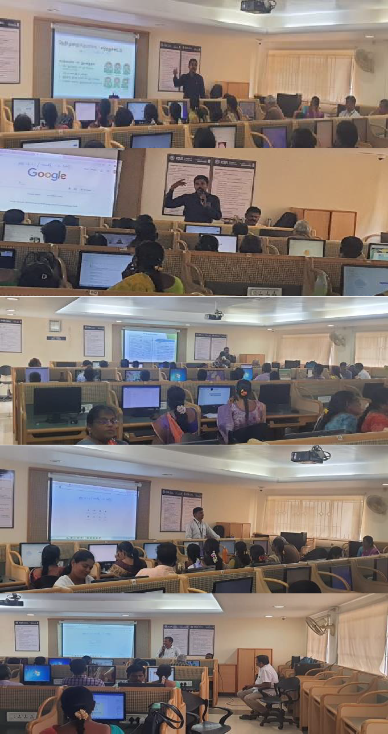
- 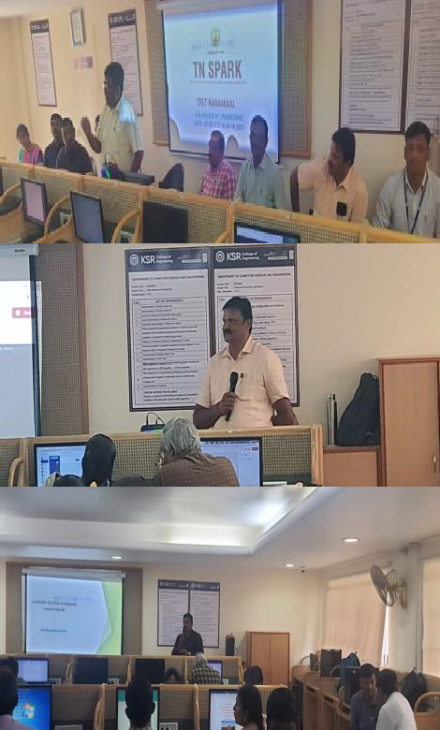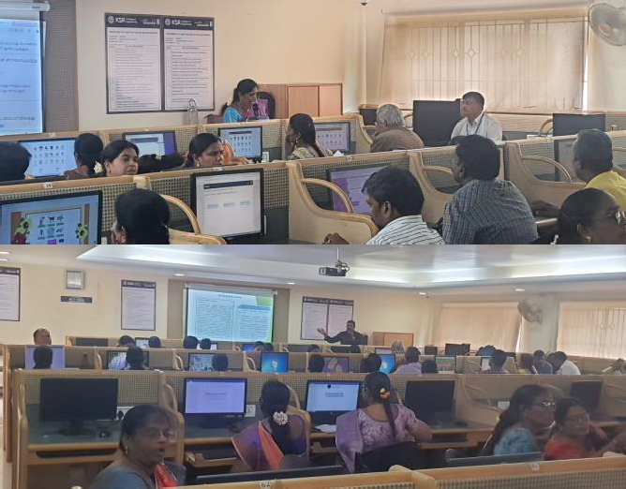Photos:

Coordinators:
1.R. Muthukrishnan. S. Lecturer
2.K. Vetharaja balson. Lecturer
3.G. Chelladurai. Lecturer

